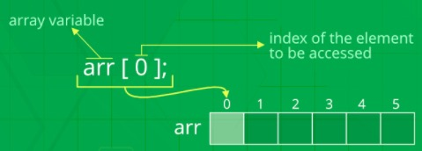**Array Operations in C++**

1. **Addition**
2. **Subtraction**
3. **Multiplication**

**Initializing an array**

**int a[3] = {2,2,2}**

**int b[3] = {3,3,3}**

**CODE:**

#include<iostream>

using namespace std;

int main()

{

int a[3],b[3],add[3],sub[3],mul[3];

cout<<"Enter values"<<endl;

for(int i=0;i<3;i++)

{

cin>>a[i];

}

for(int i=0;i<3;i++)

{

cin>>b[i];

}

cout<<"Add, sub, mul are"<<endl;

for(int i=0;i<3;i++)

{

add[i]=a[i]+b[i];

cout<<add[i]<<" ";

}

cout<<endl;

for(int i=0;i<3;i++)

{

sub[i]=a[i]-b[i];

cout<<sub[i]<<" ";

}

cout<<endl;

for(int i=0;i<3;i++)

{

mul[i]=a[i]*b[i];

cout<<mul[i]<<" ";

}

cout<<endl;

}

**2-Dimensional arrays in C++**

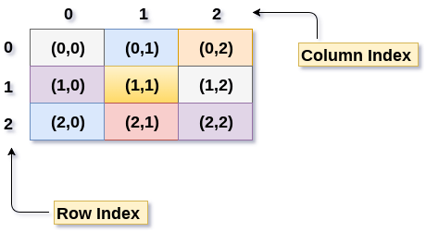

**Single dimension array**

**int myarr[5];**

**Two dimension array**

**int myarr[5][5]; //rows & columns**

**int array_type1[5][5]; //declare 2D array**

***INITIALIZATION OF ARRAY***

int array_type2[2][2] = { 1, 2, 3, 4 };

**//(0,0)=1, (0,1)=2,(1,0)=3, (1,1)=4**

int array_type3[3][3] = {{1,1,1},{2,2,2},{3,3,3}};

**CODE:**

#include<iostream>

using namespace std;

int main()

{

// perform addition

int a[3][3], b[2][2], add[2][2], sub[2][2], mul[2][2];

cout<<"enter the values for array a"<<endl;

for(int i=0;i<3;i++)

{

for(int j=0;j<3;j++)

{

cin>>a[i][j];

}

cout<<endl;

}

cout<<"enter the values for array b"<<endl;

for(int i=0;i<2;i++)

{

for(int j=0;j<2;j++)

{

cin>>b[i][j];

}

cout<<endl;

}

for(int i=0;i<2;i++)

{

for(int j=0;j<2;j++)

{

add[i][j]=a[i][j]+b[i][j];

}

cout<<endl;

}

for(int i=0;i<2;i++)

{

for(int j=0;j<2;j++)

{

sub[i][j]=a[i][j]-b[i][j];

}

cout<<endl;

}

for(int i=0;i<2;i++)

{

for(int j=0;j<2;j++)

{

mul[i][j]=a[i][j]*b[i][j];

}

cout<<endl;

}

cout<<"addition is"<<endl;

for(int i=0;i<2;i++)

{

for(int j=0;j<2;j++)

{

cout<<add[i][j]<<" ";

}

cout<<endl;

}

cout<<"subtraction is"<<endl;

for(int i=0;i<2;i++)

{

for(int j=0;j<2;j++)

{

cout<<sub[i][j]<<" ";

}

cout<<endl;

}

cout<<"multiplication is"<<endl;

for(int i=0;i<2;i++)

{

for(int j=0;j<2;j++)

{

cout<<mul[i][j]<<" ";

}

cout<<endl;

}

return 0;

}